Destination | 7KM | 13KM
C1: Panthers Port Macquarie to Port Macquarie Koala Hospital | Hop on bus from C1 to C2 (30 -minutes) | Walk C1 to C2 = 3.8KM (60-minutes)
C2: Port Macquarie Koala Hospital to 4/4 Flynn Street | 650M (10 minutes)
C3: 4/4 Flynn Street to Flynns Beach | 500M (10 minutes)
C4: Flynns Beach to Rocky Beach Lookout | 550M (10-minutes)
C5: Rocky Beach Lookout to Flagstaff Lookout | 1.2KM (15-minutes)
C6: Flagstaff Lookout to Town Beach Lookout | 1KM (12-minutes)
C7: Town Beach Lookout to Shark Sculpture | 1.5KM (20-minutes)
C8: Shark Sculpture to Panthers RSL | 1.3KM (15-minutes)
*ESTIMATE 1KM = 12 – 20 minutes depending on the individual

Welcome to the Move8 Walk-a-Hunt in Port Macquarie. This is not a race, rather, it’s a walk that embraces nature and every ability.
Slow down. Take your time. Enjoy your walk and stay safely on the path.

To view the full map, visit:
www.sportsfitnessfestival.com/move8
Location: Panthers Port Macquarie, 1 Bay Street, Port Macquarie, 2444 NSW.

Checkpoint 1: Clue: Find your 8.

AFT International Sports Fitness Festival and Port Macquarie-Hastings Council welcomes you with a big shout-out! Get ready to puff a little on this walkabout exercise that seeks to sniff out Port Macquarie's popular hotspots,
In-person or Virtual, we invite you to gather in groups of eight lots, why 8 you ask? Click to watch a short video on the Move8 Method of Wellness to begin your quest for living your best! Here’s the link: https://youtu.be/v9m13-mjq4E
A community of 8 workout besties have been suggested by many in history, Eight is an ideal number for team support to maximise effects, sharing goals with a team makes it fun and you’ll make new friends in fact! Enjoy the company while achieving your individual health and wellness goals.

Checkpoint 1, Mission: Find your 8.
1. Snap a photo or a video with 8 others, strangers, or friends. Share your photo or video on any Social Media platform.
2. Hashtag #IlovePortMacquarie #move8 #spofife #sportsequity #diversitybyinclusion
On Facebook: @GreaterPortMacquarie @asiafitnesstoday @funfitfriday
On Instagram: @portmacquarie @afitnesstoday.official
On Twitter: @PMQTourism @move8movement

Location: Settlement point bus stop

Checkpoint 2, CLUE: Listen by heart.
Now that you've found your 8, the Koalas need your aid,
You may walk if you want but a bus could bring you quickly, go now don’t wait,
Walk or hop on a short bus ride from Settlement City to an 1890s home once owned by Flynn,
Beside Roto House, you’ll find no inn, but a koalaseum and the oldest rehabilitation hospital in all of Australia, The Port Macquarie Koala Hospital is where these fluffy friends are rescued, rehabilitated, and released back to the wild,
The work needs your attention and donations if you can, see for yourself and you’ll understand, these adorable marsupials need a helping hand, Thanks for your donation, whatever the amount! The koalas are in the care of some 200 volunteers and every cent counts.
Now the koalas are in good hands, let’s keep an eye out for that beautiful person reading this too! Yes, that’s you! A healthy body requires a healthy mind, give your heart's desire a listen, find a quiet and safe spot along the way, and write down your health goals. What advise do you hear when listening by heart?
Quick catch that bus if it’s the 7KM route you’re after,
Otherwise, it’ll be 13KM that starts from here on foot, to the Port Macquarie Koala Hospital route.

Bus options:
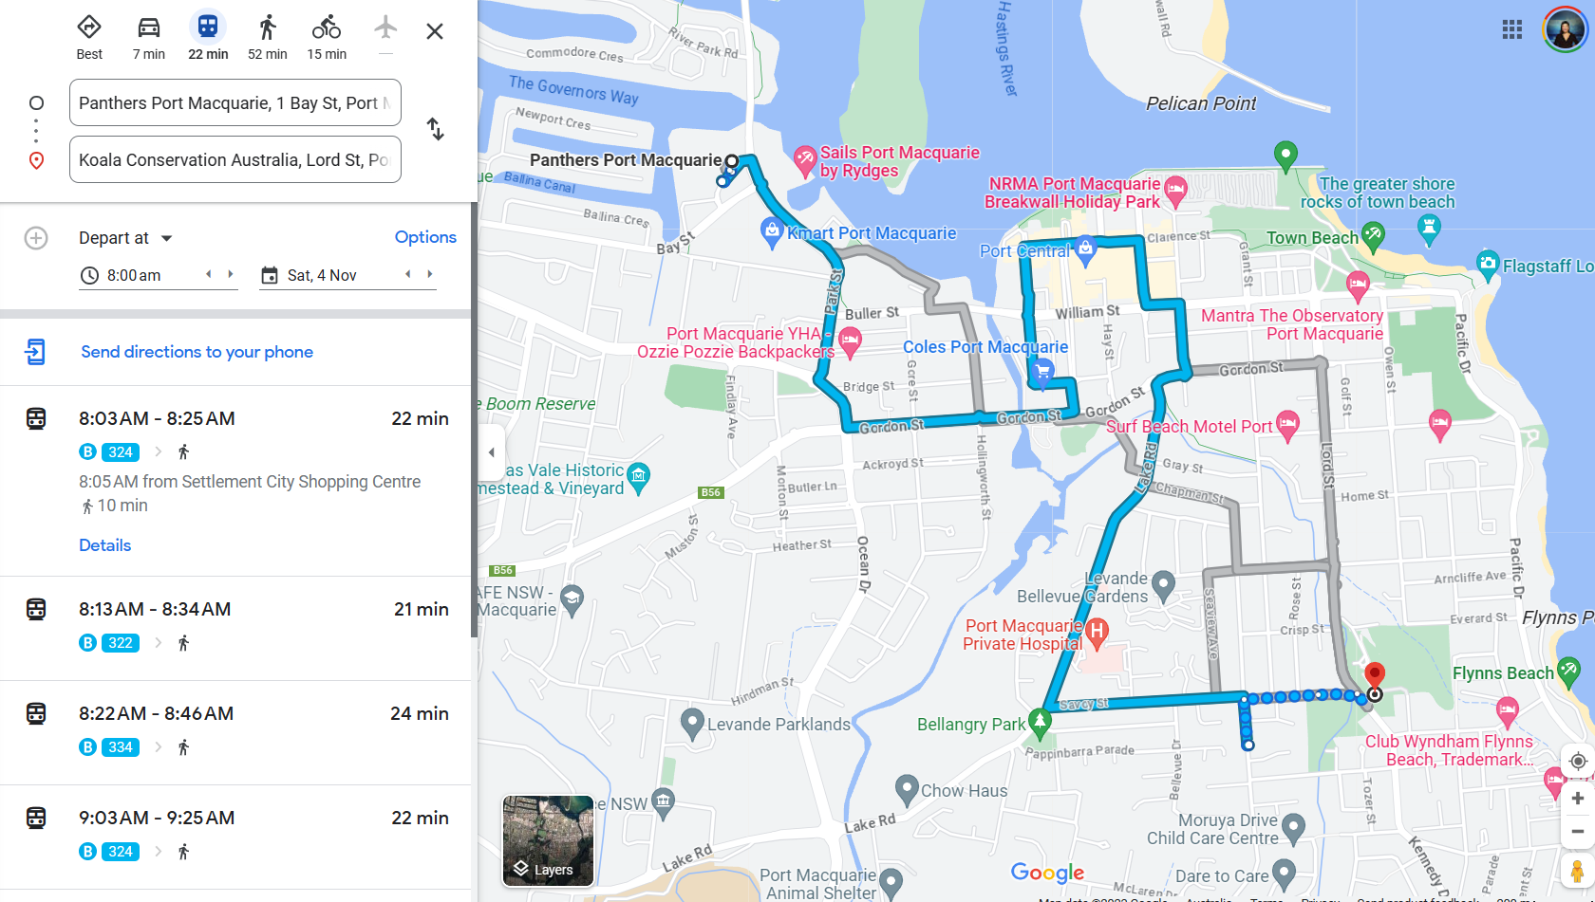

Meeting Point Location: Port Macquarie Koala Hospital

Checkpoint 2, Mission: Listen by Heart.
Welcome to the Port Macquarie Koala Hospital!
1. Every year over (50) (350) (500) koalas are rescued and admitted in this hospital alone. Circle the right answer.
2. I want to be a (Volunteer) (Donor) (Ambassador) - this is optional, of course, however isn’t it amazing to note that the hospital is supported by over 200 volunteers? Kudos to each one of them!
3. Snap and share a photo or video of you with your favourite koala in any social media.
4. Hashtag #Move8 #iloveportmacquarie #spofife #sportsinclusion #diversitybyinclusion #portmacquariekoalahospital

Meeting Point Location: 4/4 Flynn Street, Port Macquarie 2444 NSW.

Checkpoint 3 Clue: Movement is Therapy.
Say goodbye to your koala as you leave them behind. To the ocean along Flynn Street we shall go and a whale we shall find. Get moving and build it up to higher intensity walks and muscle building with resistance exercises.
A whale of a time with tantalising culinary temptations from another world awaits at your next destination.
Exercise is Medicine Society prescribes walking at every opportunity and when you incorporate sporting activities into your social life, you won't help but enjoy life to the full. As they say, 2, 4, 6, 8, Move8, don't wait!

Checkpoint 3, Movement is Therapy Mission:
1. Stopover at the Blue Whale Asian Eatery and await further instructions.
2. Level up your exercise intensity at right where you are. For movement is therapy for our mental well-being too! Give us your 66 Sit-ups now, or later. Do it 21 days in a row and get 6 friends too. For mental health, for the Sit-ups Challenge, click here to learn more: https://the-situp-challenge.raisely.com/.
3. Take a photo or video of you doing at least 6 sit-ups and share it with 6 friends or on any Social Media platform.
4. Hashtag
#iloveportmacquarie #Move8 #spofife #sportsinclusion #diversitybyinclusion #situpchallenge #mentalwheelsfoundation
Facebook: @GreaterPortMacquarie @asiafitnesstoday @funfitfriday @mentalwheels
Instagram: @portmacquarie @afitnesstoday.official @mentalwheelsfoundation
Twitter: @PMQTourism @move8movement

Location: Blue Whale Asian Eatery (googlemaps), 4/4 Flynn Street, Port Macquarie New South Wales 2444

Checkpoint 4 Clue: Food is Life.
We all need food to survive whether braised, grilled, freshly cut or fried. But when you speak of Asian Food; there is more than meets the eye.
At the Blue Whale Asian Eatery n Bar on Flynn; passing Surf Street is where we shall meet. However, their Takeaway opens only from 5.00 pm and it does not open too late! This family friendly with a relaxing and comfortable atmosphere is here so to the Menu we seek and make our choices and whet our appetite.
Food nourishes us. Understanding and knowing how your body reacts to the types of foods you eat can improve your well-being.

Checkpoint 4 Mission:
1. Create a personal menu with a dish or two each from a different nation.
You can create a personal menu by selecting a dish of your choice from a different nation at this eatery and bar. Share with us what you'll have for Starters, Main Meal & Dessert from the Blue Whale Asian Eatery n Bar.
Hint: google the restaurant and view the menu from there.
2. Share your menu options in any Social Media and say, "A Secret Supper here? My choice of meal here would be (enter your answer)"
Hashtag #iloveportmacquarie #Move8 #spofife #secretsupper #eatforgood #bluewhaleasianeatery
Facebook: @GreaterPortMacquarie @asiafitnesstoday @funfitfriday @bluewhaleasianeatery
Instagram: @portmacquarie @afitnesstoday.official

Location: Flynns Beach, Port Macquarie New South Wales 2444

Checkpoint 5 Clue: Rhythm & Beats.
Move8 to the beach and feel the rhythm and the beats. Your next Checkpoint is at Flynns Beach but you have to cross the street.
Huff and puff, pump your heart babadom! A good workout when you are done.
Look left then look right, cross over Pacific Drive to the other side then take a right. Walk alongside safely then turn left onto Tuppenny Road and behold; down to the beach is where you need to go.
There is a Father & Son; and surfing is their lore.They have a story to tell and a "Board Meeting" is in store. Meet the family behind one of Port Macquarie's surfing community and hurry, you better get going!
Come talk to them and find out more. To be sure you found the right spot; here on Flynns Beach look for the surf boards.

Checkpoint 5 Mission:
1. Give us your killer surf pose and away you go!
2. Upload your photo or video and sign up to join us at the surf.
3. Hashtag #iloveportmacquarie #portmacquariesurfschool #spofife #sportsinclusion #diversitybyinclusion #move8

Location: Breakwall Town Beach, Port Macquarie New South Wales 2444
Checkpoint 6 Clue: Sleep Science.
Whoa! After all that activity the last thing you will do is go to sleep. However, World Sleep Society research shows that routine and uninterrupted sleep could result in lower rates of diabetes and obesity, chronic illnesses, and high blood pressure.
Up ahead at Town Beach is a caravan site generous in size. One is called Breakwall Holiday but it's the great Boardwalk with beautiful painted rocks we hope you will miss not.
There are two among the many that we want you to find.
One is meaningful, the other a message of hope.
Carefully look for them along the coast and you may even discover others that speaks to you the most.

Checkpoint 6 Mission:
1. Find these two painted rocks and fill in the missing words. The family that __ together __ together. Maybe you're the __ in someone else's storm.
2. Snap a photo or video and share it in any social media.
3. Hashtag #iloveportmacquarie #breakwall #townbeach #move8 #spofife #sportsinclusion #diversitybyinclusion

Location: Shark Sculpture, Port Macquarie New South Wales 2444

Checkpoint 7 Clue: Growth is Constant.

Some 40,000 years ago was home to the Birpai.
The original occupants of this land,
Their traditions, culture and heritage we seek to understand.
Aboriginal and Torres Strait Islanders,
A complex system of spiritual beliefs and cultural practices.
Their "Totems" provide a link between the natural world and kinship relationship.
A shark, eagle, kangaroo, bass, stingray or crab.
These are but a few examples of Birpai Totems at best.
It was their responsibility to maintain their obligation,
But today it is your Mission to find one for conservation.

Checkpoint 7 Mission:
1. Look around here or for a kilometre a "Totem", symbol for a great cause. A modern depiction by Roberto Giordani, his artwork aptly called Decomporsi. Go find it; a fish out of water and hoisted above the sea for all to see.
2. Snap a photo or video and share it in any Social Media.
3. Hashtag #iloveportmacquarie #sharksculpture #birpai #townbeach #move8 #spofife #sportsinclusion #diversitybyinclusion

Location: Panthers Port Macquarie

Checkpoint 8 Clue: Mindset Shift.
Now, that was a "Shark Attract" that you will survive to make your way back to Checkpoint 8.
There is however another Shark in town that's formed in 1940 from Port Macquarie and in this sport is where they seek their glory.
Together with the Panthers, they remain competitive in the sport of Rugby. Some may even call it stiff rivalry.
Make your way to the final Checkpoint at Panthers RSL where we will help you level up your mind in turn.
May what you have experienced today be your pillars of wellness and your guide to your own personal quest for living your best and healthiest life.

Checkpoint 8 Mission:
1. At Checkpoint 8 you can also turn the 8 into aid, Move AID. Our purpose partners give good reason to be Fit for Good, so fitness enthusiasm can be channelled towards a good cause or three.
2. Choose any or all of these causes below to champion by sharing a post on any Social Media about what they do.
- A local community hero dojo, the Shinkyokushin Karate Port Macquarie Dojo for their Karate Kids on the Spectrum program - www.portkarate.com.
- The conservation work by the Port Macquarie Koala Hospital is the pride of the Greater Port Macquarie district. Adopt a koala, volunteer or visit www.koalahospital.org.au to learn more!
- All Together Now is the charitable organisation that champions racial harmony programmes and counters far-right extremism and hateful fake news and conspiracy theories – www.alltogethernow.org.au.
3. Hashtag #ILovePortMacquarie #SportsFItnessFestival #Move8 #SportsEquity #DiversitybyInclusion

CONGRATULATIONS!
You have completed the Port Macquarie route!

